|  |  |  |  |  |  |  |
| --- | --- | --- | --- | --- | --- | --- |
| **Test Name** | | | Crown & Anchor – Retest Bug 1 | | | |
| **Use Case Tested:** | | | Game does not pay out at correct level | | | |
| **Test Description:** | | | Run the game and observe if player’s balance does not increase in one match (after fixing bug) | | | |
| **Pre-conditions** | | | Single run of main() method to produce 100 games | | | |
| **Post-conditions** | | | n/a | | | |
| **Notes:** | | **Given the large number of turns in a single run (100 games x up to 100 turns), only the first 10 positive results will be observed and recorded or all results for the 100 games if less than 10 observations.**  **No test data are available to use as the main() method hard-codes the input data.** | | | | |
| **Result (Pass/Fail/Warning/Incomplete)** | |  | | | | |
|  | **TEST STEP** | | | **EXPECTED TEST RESULTS**  **ACTUAL TEST RESULTS** | P | F |
|  | Observe if player’s balance does not increase in one match (any dice matched) | | | Players balance now does increase in 10 observations  Actual results do not confirm the hypothesis – see Screenshot 1 below – the player’s balance now increases when he wins a match against the dice. |  |  |
|  | Observe if player’s balance does not increase in two or three matches | | | Players balance now does increase in 10 observations when two or three matches occur  Actual results do not conform the hypothesis – see Screenshot 1 below – the player’s balance now increases proportionately when he wins in two or three matches of the dice. |  |  |
|  | Observe if player’s balance reduces in one match | | | Players balance does reduce in 10 observations  Actual results confirmed the hypothesis – see screenshot 2. |  |  |
|  | Observe if player’s balance does not increase when a match occurs for each type of dice roll (for six types), i.e. the player’s balance does not increase in one match no matter what the type of dice roll. | | | Players balance now does increase in 10 observations for HEART, ANCHOR, CLUB, DIAMOND, CROWN, or SPADE match  Actual results confirmed the hypothesis, and “Bug 6” (later known as Bug3a) was observed to be fixed: that a SPADE is now rolled in the game – see screenshot 3. |  |  |

|  |  |  |  |  |  |
| --- | --- | --- | --- | --- | --- |
| **Test Data Table** | | | | | |
|  | **1** | **2** | **3** | **4** | **5** |
| Player Name | “Fred” (set by default) |  |  |  |  |
| Games played | 100 (set by default) |  |  |  |  |
| Turns played | Until balance is 0 (set by default) |  |  |  |  |

# Screenshots

Screenshot 1:

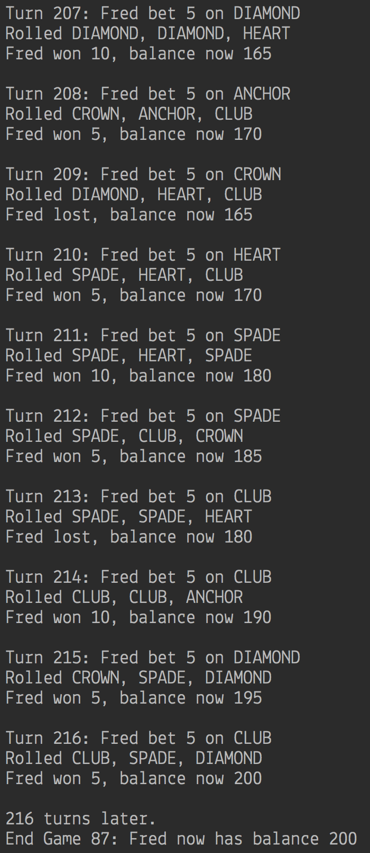

Screenshot 2:

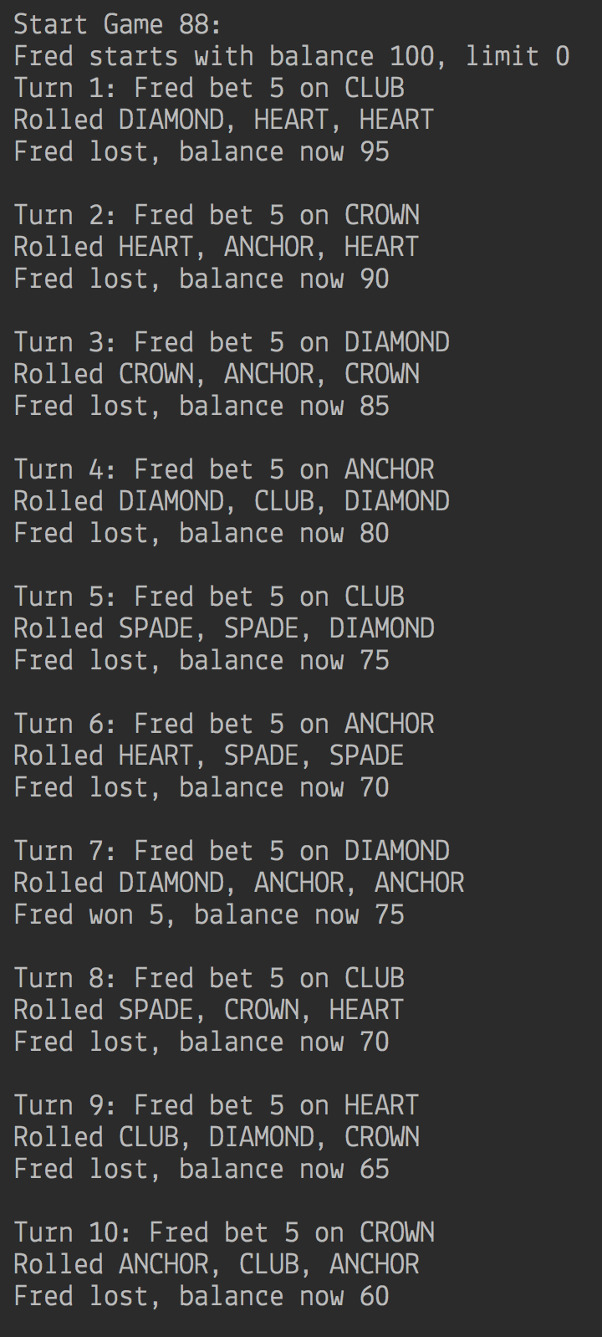

Screenshot 3:

